Khamlia Mehdi
Ezzahra, Tunis TUNISIA
Email ID: mehdi.khamlia2@dxc.com  Contact no: 216 - 98 603 013  Nationality: Tunisian  N° CIN : 07039118  Familial Statut : Maried  Adress : A32 Résidence Ennarjess Boumhel  Tél : 98603013  Personnal Email : mehdi.khamlia@outlook.com | 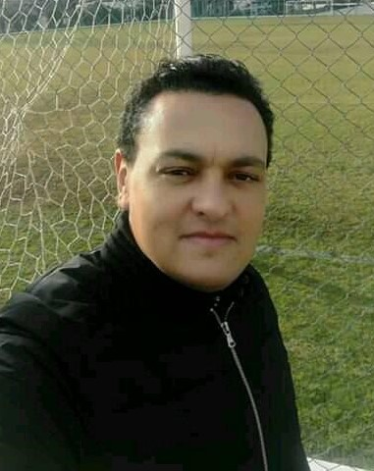
- Profile
Total experience: 14 years in IT services | DXC experience: 3 years, 5 Months
Current Job Title: Technical Automation Lead | Time in Current Role: 1 year, 5months
- Diploma and Certification:
1. BACCALAUREAT ECONOMICS AND MANAGEMENT at IBN Rachic Ezzahra.
2. DUEL MANAGEMENT at the University of Campus El MANAR II (FSEGT).
3. HIGHER TECHNICIAN DIPLOMA WEBMASTER at IMSET.
4. BACHELOR (LICENCE) LASTIC at UVT.
5. CERTIFICATION Full Stack Web Developer at Udemy.
6. CERTIFICATION DevOps at SkillSoft. (on going)

- Capability:
- Configure Servers and operating system and the dependencies between the different Web Application components.
- Design manipulate and Query DataBases.
- Design the Front-end code that is executed on the user's platform, in languages such as Javascript and its FrameWorks, HTML and CSS.
- Design Back-end code and APIs to access this data as webservices, using languages such as Nodejs, PHP, Python.
- Able to manage and to deploy projects with DevOps and Agility technics to interact with the Client and his needs.
- Technical Skills:
- HTML / CSS
- JAVASCRIPT & FrameWorks
- PHP
- PYTHON
- SQL Language / DB Design
- POWERSHELL / VBS
- SysAdmin (Linux, Windows, Apache, IIS, Etc…)
- Cloud Computing
- Data Storage
- Virtualization
- Networking

- Professional Work Experience:
    - 2000 Internship in Poulina in the accounting section.
    - 2001 NBM Like Web & Graphic Designer.
    - 2002 SIM Computer IT Hardware and Networks Fix.
    - 2003 Positive Tunisia Web Developer (Web App).
    - 2004 Central University UCAAT IT Manager.
    - 2004 -2017 In my IT business (Computer Services).
    - 2018 CPL Technical Support Analyst.
    - Since 2018 In DXC Technologies as a Technical Automation Lead.
- Languages:
- ARABIC – Oral and Written Proficiency ****
- FRENCH – Oral and Written Proficiency****
- ENGLISH – Oral and Written Medium***
- ITALIEN – Oral and Written Medium ***

